Case Study 8. Millennium Development Goals, in particular MDG 1c relating to hunger and nutrition
Abstract

MDG 1 commits to eradicate extreme poverty and hunger, sub-goal MDG 1c of which specifically commits to halve by 2015 the proportion of people who were suffering from hunger in 1990. Progress towards achieving this goal is reviewed, drawing on the joint FAO, IFAD and WFP report “The State of Food Insecurity in the World, 2014”, and the retrospective mid-2015 version of their joint annual report. Many countries have achieved the Goal, whilst others have not. The regional context, indicating which regions were better achievers than others is discussed.
Key words: MDG 1c; hunger and extreme poverty; MDG Summit 2010
8.1. Introduction
In September 2000, world leaders came together at UN headquarters in New York to address some of the key development challenges facing the planet at that time. The Summit was well-prepared for, with many reports and consensus-gathering discussions and conferences, not least amongst NGOs and CBOs, representing civil society. The outcome of the Summit was a raft of eight development goals (and 21 targets), which came to be known as the Millennium Development Goals (MDGs).
The United Nations Millennium Declaration which enshrined these Goals was signed by representatives of all member countries, 189 at that time, including 147 Heads of State and Governments. More than twenty international organizations also signed. The Goals, which all signatories would attempt to achieve by 2015, committed world leaders to combat poverty, hunger, disease, illiteracy, environmental degradation and discrimination against women. The MDGs all had specific targets and indicators necessary to monitor their degree of achievement. Despite criticisms levelled at the concept of Goals (such as the legitimacy of their derivation, their underlying analytical framework and difficulty in measuring achievement for some of the targets), the MDGs have nevertheless provided an international political and operational framework and focus for incremental measures to improve the human condition in the developing world, and fund-sourcing to enable that. Coordinated policies and actions were needed to address the MDGs across a range of sectors, and these sectors are intimately related.
At the subsequent MDG Summit to review progress in September 2010, UN Member States initiated steps towards advancing the development agenda beyond 2015. In June 2012 at Rio+20, the UN Conference on Sustainable Development, UN Member States adopted the outcome document ‘The Future We Want’, which sets in motion many of the inter-governmental processes for the post-2015 development agenda, to be tabled for adoption by UN Member States at a Summit in September 2015.

The Goal which specifically targets food security (and nutrition security), is MDG 1, which seeks to “eradicate extreme poverty and hunger”, both components being bi-causally related. The means to achieve MDG 1 were foreseen as including increased agricultural productivity, production and profitability, value-adding, job creation, better health care and home care, and better governance. Achieving the other seven MDGs should indirectly serve to address MDG 1, which itself had three targets:
MDG 1a: Halve, between 1990 and 2015, the proportion of people whose income is less than $1.25 a day
MDG 1b: Achieve full and productive employment and decent work for all, including women and young people
MDG 1c: Halve, between 1990 and 2015, the proportion of people who suffer from hunger
Through seeking to generate incremental income directly, MDG 1a and 1b addressed the economic access component of food security. MDG 1c was intended to reduce the proportion of hungry people in the developing world from 23.6 percent (as it was in the 1990 base year) to 11.8 percent by 2015. The two indicators for monitoring purposes for MDG 1c are listed as:
- Prevalence of underweight children under-five years of age
- Proportion of population below the minimum level of dietary energy consumption [viz. the proportion which is undernourished (hungry)]
These indicators were intended to be disaggregated by sex, and whether urban or rural. Norms for these indicators were country-specific.
8.2. Progress towards achieving MDG 1c

FAO, IFAD and WFP (2014) provided a stock-taking of progress towards achieving the hunger component of MDG 1, as the deadline of 2015 loomed. A number of country case studies were presented, continuing the practice established in the previous year’s stock-taking exercise. It estimated that global hunger reduction continued, with about 805 million people (one ninth of the world’s population) chronically undernourished over 2012–14, down more than 100 million over the previous decade, and 209 million lower than over 1990–92. Of those 805 million, 791 million were from developing countries, down by 203 million since 1990–92. Over the same 24-year period, the prevalence of undernourishment had fallen from 18.7 to 11.3 percent globally, and from 23.4 to 13.5 for developing countries. China alone had reduced the number of undernourished people by 138 million over this period, while the 10 countries that had achieved greatest success in reducing the total number of hungry people in proportion to their national population were: Armenia, Azerbaijan, Brazil, Cuba, Georgia, Ghana, Kuwait, Saint Vincent and Grenadines, Thailand and Venezuela. The global hunger target of MDG 1c was regarded as within reach. However, the developing world was not on track to achieve the more stringent 1996 World Food Summit goal, which was that the absolute number of hungry in 1996 should be halved by 2015.

Global progress in hunger reduction mainly reflected achievements made in countries which by 2014 had already met the MDG 1c target of halving the proportion of undernourished people by 2015. Sixty-three developing countries had already reached that target according to the FAO/ IFAD/ WFP Report of 2014, 11 of which having maintained the prevalence of undernourishment below 5 percent since 1990–92, while another six were on track to do so by 2015. Of the sixty-three countries assessed, twenty-five had also accomplished the more ambitious 1996 World Food Summit goal of halving the number of chronically underfed people between 1990 and 2015.
The report on The State of Food Insecurity in the World 2014 includes seven country case studies that summarize how and to what extent those countries have sought to create an enabling environment for food security and nutrition. A message emerging from that report is that accelerated, substantial and sustainable hunger reduction is possible with the requisite political commitment. This has to be well informed by a sound understanding of national challenges, relevant policy options, lessons learned from other experiences and broad participation. Such broad participation to secure wide ownership of planning decisions involves consultation at grass roots level with those whose livelihoods and food security are most affected by those decisions, as well as politicians who need to endorse them (see photos below).

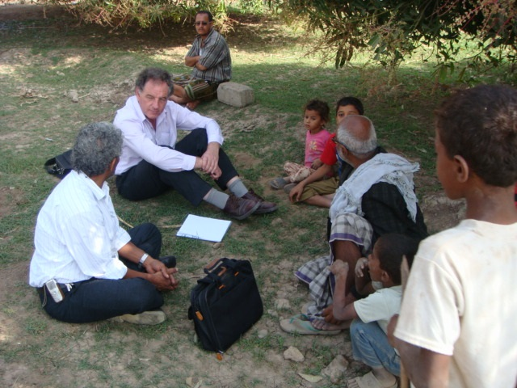
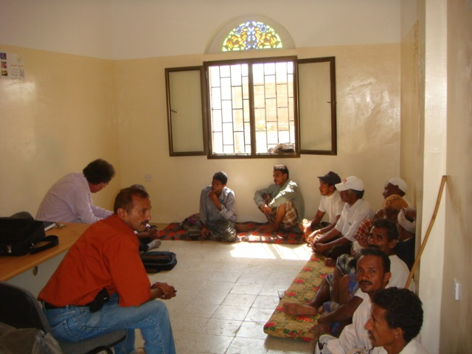

Photo 8.1 and 8.2. Management of the Tihama Plains watershed in Hoddaidah governorate, Yemen, informed by discussions with members of water user and farming associations, in a spate-irrigated mango grove and an agricultural department office (photographs: Jafaar Hasan Alawi Al-Jeffri).

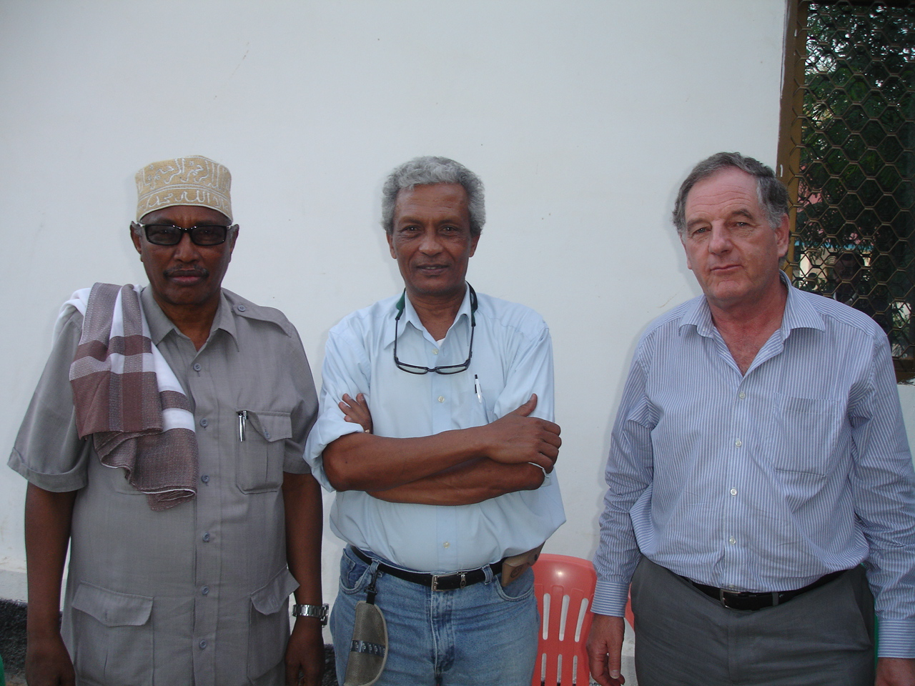
Photo 8.3. A team member of an external mission on behalf of the EC to the autonomous region of Puntland, Somalia in 2011, to identify possible components of an economic growth program, discussing options with President Abdirahman Mohamud Farole at Puntland State House, Garowe.

8.3. Retrospective assessment of achievement of MDG 1c
The “State of Food Insecurity in the World, 2015” (FAO, IFAD and WFP, 2015) (‘the 2015 Report’ hereafter) provides a retrospective on the global effort over the previous fifteen years to achieve MDG1c, albeit based on informed estimates. This Report marks the end of the monitoring period of attainment of the targets of all the MDGs, and the transition to the post-2015 Sustainable Development Agenda. Compared with the previous year’s Report, an extra ten million people had been removed from the 805 million ‘hungry’, the new estimate being 795 million, of which 780m are in the developing world. The 795m figure is 216m fewer than in 1990-92, representing a 21.4 percent reduction, this in the face of a 1.9 billion increase in total population over the same period.

The proportion of undernourished people globally decreased from 18.6 percent in 1990-92 to 10.9 percent in 2014-16. The equivalent figures in the developing world are 23.3 percent in 1990-92 to 12.9 percent in 2014-16, this representing a 44.5 percent reduction since 1990-92; underlying this powerful performance were the marked achievements of two large and populous countries, China and India.
Though the 2014 Report had believed that the global target of halving the number of the world’s hungry in 1990 could be reached by 2015, the 2015 Report regretted that globally this had not quite been achieved. However, as the estimated reduction by 2014–16 is less than one percentage point away from that required to reach the target, allowing for a margin of error of the background data used to estimate undernourishment, authors of the 2015 Report regard the global target for MDG1c as having been met (Figure 8.1).
Figure 8.1. The trajectory of undernourishment in developing regions: actual and projected progress towards the MDG and WFS targets
Source: Figure 1 (page 9), from FAO, IFAD and WFP (2015). The State of Food Insecurity in the World 2015. Meeting the 2015 international hunger targets: taking stock of uneven progress. Rome, FAO - http://www.fao.org/3/a-i4646e.pdf - reproduced with permission of FAO.
There were strong regional variations however, with some making exemplary progress, including Latin America; Central, East and SE Asia; and, Northern and Western Africa. In two regions, however, southern Asia and Sub-Saharan Africa, progress has been slow overall, though at individual country and sub-Regional levels there are success stories. Reduction of hunger clearly remains a particular challenge in these two Regions (Chapters 4 and 5 of the companion book address some of the means to do this)(Figure 8.2 below).
Figure 8.2. The changing distribution of hunger in the world: numbers and shares of undernourished people by region, 1990-92 and 2014-16.
Source: Figure 2 (page 10), from FAO, IFAD and WFP (2015). The State of Food Insecurity in the World 2015. Meeting the 2015 international hunger targets: taking stock of uneven progress. Rome, FAO - http://www.fao.org/3/a-i4646e.pdf - reproduced with permission of FAO.

The other global target, set by the WFS in 1996, has been missed by a significant margin. The number of undernourished people in 1990–92 is estimated at around one billion in the developing regions. The 2015 Report calculates that meeting the WFS goal would have required bringing this number down to about 515 million, that is, some 265 million fewer than the current estimate for 2014–16 (780 million). However, considering that the population has grown by 1.9 billion since 1990–92, about two billion people today have been freed from a likely state of hunger as a result of efforts over the past 25 years.
The estimates in the 2015 Report indicate that Latin America and the Caribbean, considered together, have achieved both the MDG 1c hunger target and the WFS goal in 2014–16. However, Africa as a whole, and sub-Saharan Africa in particular, did not achieve the MDG 1c target. Northern Africa, by contrast, has reached the target. The more ambitious WFS goal, however, appears to be out of reach for Africa as a whole, as well as for all its sub-regions. Asia as a region has already achieved the MDG 1c hunger target, but would have needed a further reduction of about 140 million undernourished people to reach the WFS goal.
72 developing countries out of the 129 monitored, attained the MDG1c hunger target, 29 of which also having reached the more ambitious WFS goal by at least halving the absolute number of undernourished people in their populations. Of these 29 countries, 7 are in sub-Saharan Africa, 5 in Eastern/ Southern/ South-Eastern Asia and Oceania, 10 in Latin America and the Caribbean, 2 in North Africa and 5 in Central Asia and the Caucasus. This reflected those countries’ stable politics and sound economic growth and social safety net policies and practices, which reached marginalised and vulnerable groups in these countries. Economic growth for the currently marginalised is crucial to provide improved livelihoods and incomes of the poor. In the 2015 Report, support to smallholders is signalled as crucial to raise productivity, food availability and disposable income levels.
Regarding the two indicators of MDG1c (see section 8.1 above), undernourishment declined more rapidly than did child underweight (a measure of long-term nutritional dysfunction in the family environment)(Chapter 1.1.2 in the companion book), suggesting that far more progress is needed in improving quality of diet, clean water and hygiene.
Of course, achieving the latter in the face of the frequent man-made disasters of late points to the overarching need for good governance, part of which is resolving political and religious differences through discussion and negotiation rather than conflict. The increased level of conflict, unrest and population displacement in particular parts of the world actually increased the number of hungry people there. The apparent increase in frequency of large-scale natural disasters adds to the context of increased vulnerability to, and occurrence of, food insecurity and undernutrition. Against this backdrop of conflict and disaster, however good are the policies and measures to protect marginalised groups and improve livelihoods, beneficial outcomes are rendered difficult or impossible to achieve. Since the late 1990’s, the world has also had to contend with several food price crises, higher energy prices, global economic recessions and rising unemployment, all taking their toll on food security of vulnerable regions and communities
The regions where progress in removing undernutrition is of particular concern
The 2015 Report points out that the highest burden of hunger in absolute terms is in Southern Asia. Estimates for 2014–16 suggest that about 281 million people are undernourished there, this being only slightly less than was the case in 1990–92. Yet there has been progress in relative terms - the proportion of undernourished has declined from 23.9 percent in 1990–92 to 15.7 percent in 2014–16. The region is on course towards a more manageable hunger burden. Most importantly, progress has accelerated over the 2005-15 decade, despite higher prices on international commodity markets.
The 2015 Report underlines that in sub-Saharan Africa, about one in every four people, or 23.2 percent of the population, is estimated to be undernourished in 2014–16. This is the highest prevalence of undernourishment for any region and, with about 220 million hungry people in 2014–16, the second highest burden in absolute terms. Indeed, the number of undernourished people increased by 44 million between 1990–92 and 2014–16. Taking into account the region’s declining proportion of undernourished, this reflects the region’s high population growth rate of 2.7 percent per year. As a result, sub-Saharan Africa has more of a challenge to its food security than does Southern Asia.
The reader can find far more detail on the current state of food insecurity in the developing world in the 2015 Report than has been presented here. A generic food security prospect for Africa is presented in Box 8.1 below.

Box 8.1. Achieving the MDG1 target and beyond in Africa
An analysis by The Economist magazine found that over the ten years to 2010, six of the world's ten fastest-growing economies were in sub-Saharan Africa. On IMF forecasts, Africa will occupy seven of the top ten places over the period 2011-15. During the decade 2000-2010 the simple unweighted average of countries' growth rates was virtually identical in Africa and Asia. During the period 2011-15 though, Africa is likely to take the lead, spearheaded by countries like Ethiopia and Mozambique. The average African national economy will outpace its Asian counterpart. Agriculture has contributed to the high GDPs measured in Africa, with growth rates averaging 3 percent per annum.
In spite of this, however, the continent has been unable to adequately address its food needs. Growth in agricultural productivity from 1990-2010 has largely been inferior to the 6 percent growth target called for in the Comprehensive Africa Agriculture Development Program (CAADP). Despite significant developments in the field of science, technology and innovations, Africa is still experiencing low crop and livestock yields compared with other regions of the world. The incidence of poverty, hunger and undernutrition continuously challenges African policy makers, researchers and development practitioners. Of the 805 million people reported by the FAO in 2014 to be chronically undernourished, the majority are in Africa. African countries have proven unable to convincingly address their problems of food security and nutrition, despite both national and international assistance efforts.
Africa’s achievement or otherwise of the MDG 1c target and beyond is largely tied to the direct impact that agricultural growth has on national economies, as well as on how the agricultural sector stimulates growth in other sectors. The Economist opines that as the population of Africa continues to grow and urbanize, and incomes rise, African agriculture and its related value chains must grow even faster if they are to meet the continent’s required food, fibre and industrial needs. Agriculture must grow to achieve not only a food-secure Africa, but an Africa that has control over its food production and consumption.

Regarding nutritional security per se, WHO (2014) reports that with regard to MDG 1c, there is evidence of improvements in children's nutritional status at the global level. The percentage of underweight children is estimated to have declined from 25 percent in 1990 to 15 percent in 2012. Stunting in children under five years of age has decreased globally from 40 percent to 25 percent over the same period. In Asia, the number of stunted children is estimated to have more than halved between 1990 (192 million) and 2012 (91 million). However, in Africa the number of stunted children increased from 46 million in 1990 to 59 million in 2012. Despite the global improvement, and especially that in Asia, around 99 million children under-five were estimated to be underweight in 2012.

